Some Last Words

Birthdays
Ellysia Bonnick September 1
Alex Camino September 3
Joanna Jakovac September 6
Timothy Jakovac September 7
Heather Lehmann September 14
Joana Luzardo September 27
Helen Watt September 28

Anniversaries
Antonio & Cecilia Menjivar September 2

Prayer Circle
Continue to lift up family and friends into God's hands. Let us lift up our brothers and sisters in Christ and ask for God’s leading in their lives. Please pray for God's leading in our lives and in the direction of Burnaby Church. We want to hear what God has in store for us.

Every Tuesday evening | Prayer Meeting at the Church (7:30 pm)
Today | Speaker: Ken Naidoo  Potluck after service  Singing & Tract distribution (Metro Town or Joyce station)
September 21 | Communion Service
September 23-October 13 | Pastor Ken Naidoo will be on leave
Save the Date:

Who to Call?
Pastor Ken Naidoo 604-367-8336
Elders Davor Jakovac 604-434-1844
Carl Bonnick 604-537-7231
Rolito Andello 604-499-4295
Bulletin Josh Andallo/Tonya Scantlebury
burnabysdabulletininfo@gmail.com
(Please have all pertinent bulletin information sent NO LATER THAN 6:00 pm Thursday evening to guarantee it appears in the bulletin)
Welcome to Burnaby
Seventh-day Adventist
Fellowship

Sharing Christ
&
Serving Others
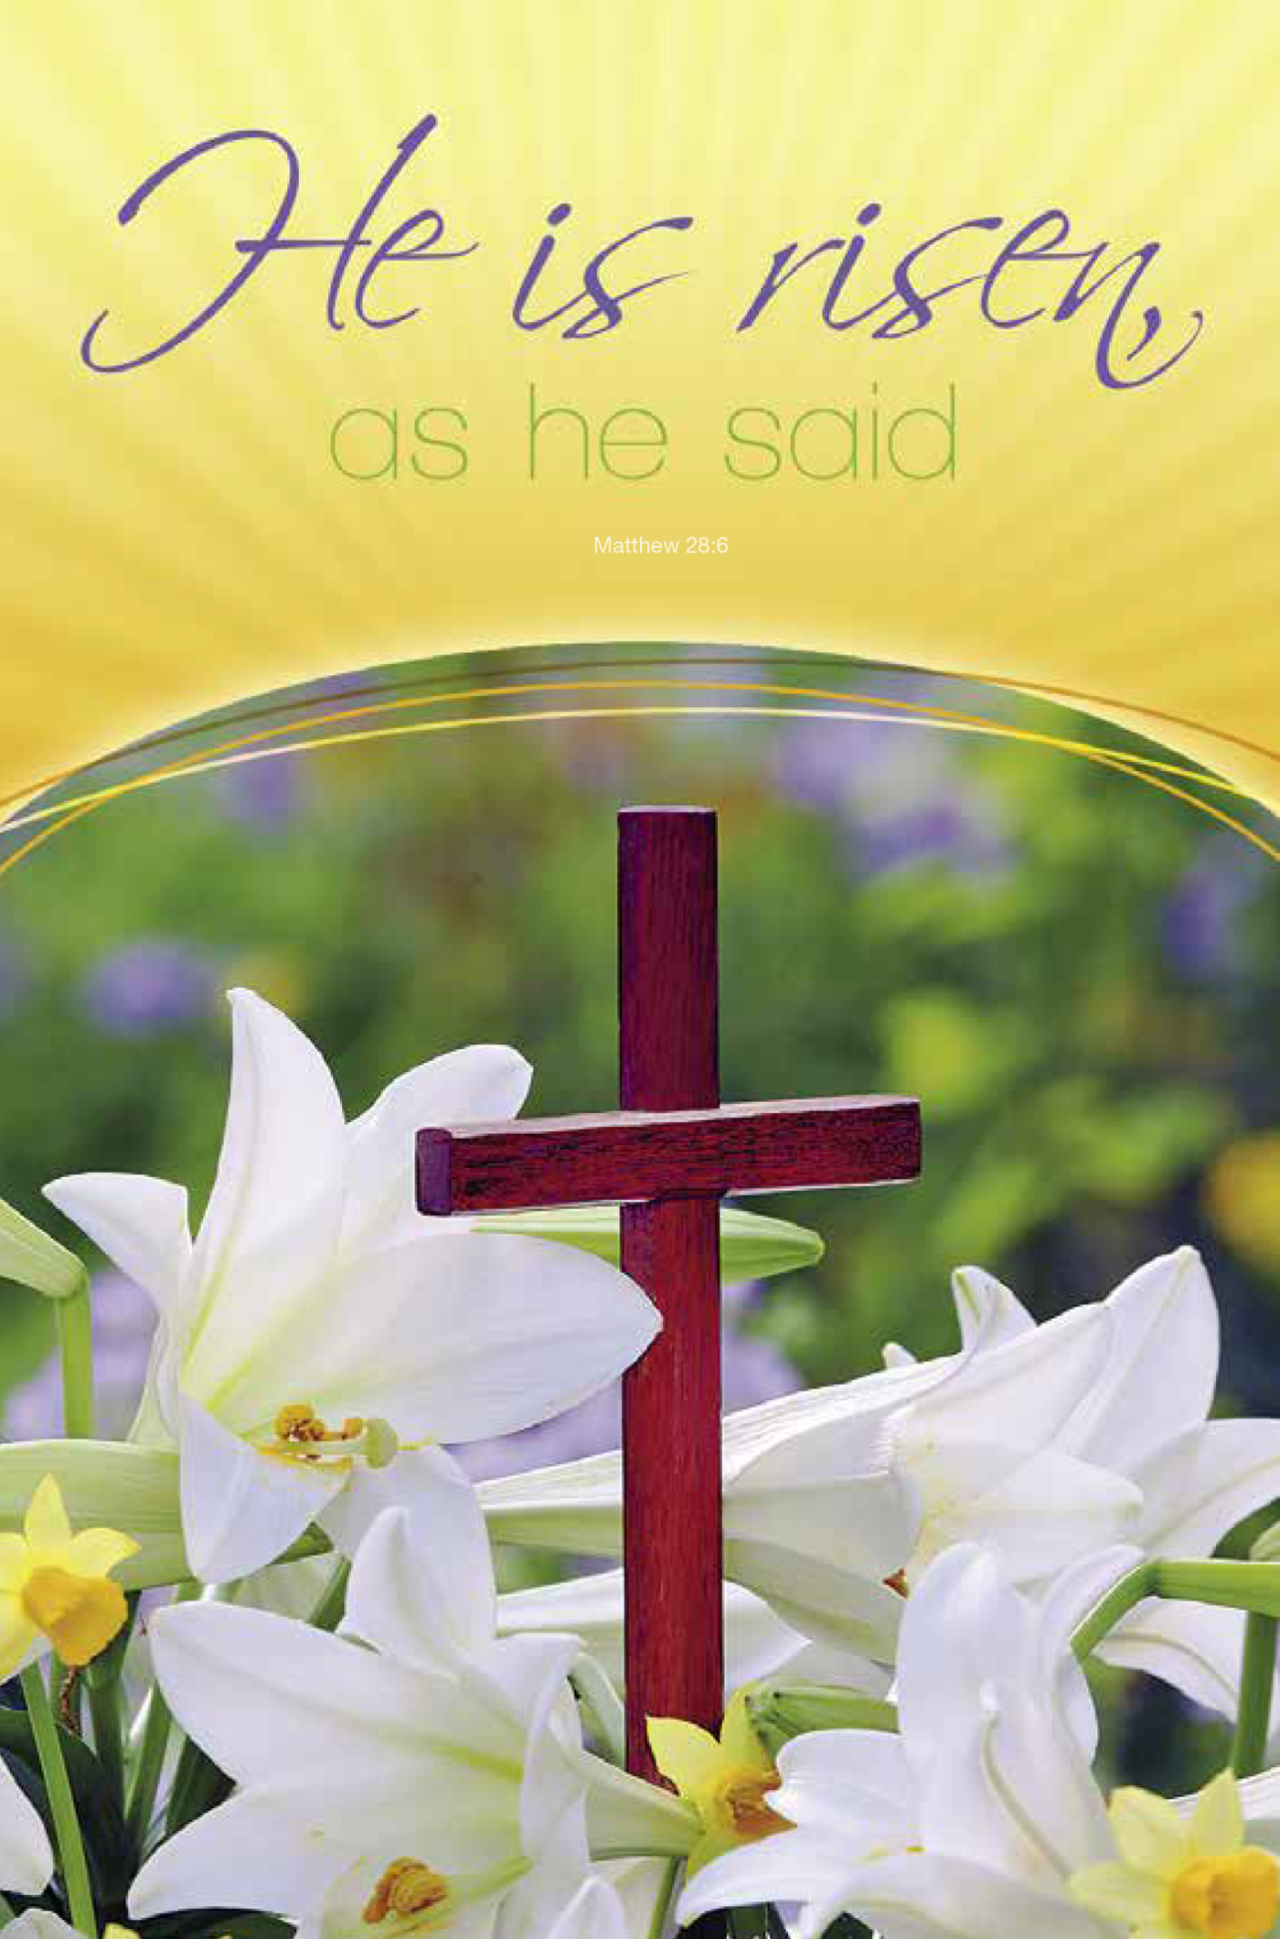

September 07, 2019
6344 Sperling Avenue
Burnaby, BC

Burnaby at Worship

Sabbath School – 10:00 am
Adults Back of Sanctuary
Teens Fellowship Hall
Juniors & Primary Fellowship Hall

Worship Service – 11:00 am - 12:30 pm
(During the worship service, please keep phones to vibrate mode or turned off)
Welcome & Announcements Tonya Scantlebury
Health Nugget Roy Johnston
Tithe & Offering Local Church Budget
Praise Time Congregation
Opening Song: Leaning on the Everlasting Arms (396)
Prayer Time
Scripture Reading
2 Corinthians 5:17-21 & 2 Kings 5:1-3
Sermon Pastor Ken Naidoo
Christ`s Ambassadors of Hope & Love
Benediction Pastor Ken Naidoo
Closing Song: I will Sing of Jesus Love (183)
Sunset Tonight: 7:42 pm Next Week: 7:28 pm
Happy Sabbath! May this day of rest and the rest of the week be a blessing to you!
Announcements
Welcome to Burnaby Fellowship!
Welcome to all those visiting with us and to every member of our church family, and thank you for choosing to worship with us today! May you feel God’s presence as we worship together!

First Nations Adventist
First Nations Adventist Training Levels 1 and 3, Indigenous wellness coach preparation will be held September 15-22, 2019 at Camp Hope, B.C. For more info and registration please visit the following links:
www.fnat.ca & www.imsdacc.com.

Women`s Ministry Retreat
The BC Conference Women's Ministries is excited to hold the 2019 Fall Retreat at Camp Hope from September 27 – 29, 2019. The speaker is Heather Quintana the editor of Vibrant Life health magazine of the Seventh-day Adventist Church. Online registration is available at www.bcadventist.ca. For manual registration contact June at 604-758-5808 or mail junebrake5@gmail.com.
The last day for registration is Thursday, September 19.

Church in the Valley Worship Academy Conference
Worship Academy Conference 2019 is happening this fall and we are excited to be hosting this impactful event!
Worship Academy Conference is a one day conference bringing together musicians, worship leaders, technicians and transformative thinkers. During this conference, you’ll be challenged to grow with action-driven sessions led by innovative leaders. We hope you will also leave refreshed as you pursue excellence in your ministry! Worship Academy 2019 will take place October 26, 9am - 6pm at Church in the Valley. To REGISTER & for more information on speakers and workshops go to: https://www.worshipacademyofficial.com

